Assignment -1
Task -1
Description: Install and configure GitHub Copilot in VS Code. Take screenshots of each step.
Expected Output: Install and configure GitHub Copilot in VS Code. Take screenshots of each step.
Prerequisites: Latest version of VS Code is installed, GitHub Account, Internet Connection
Step 1: Open VS Code
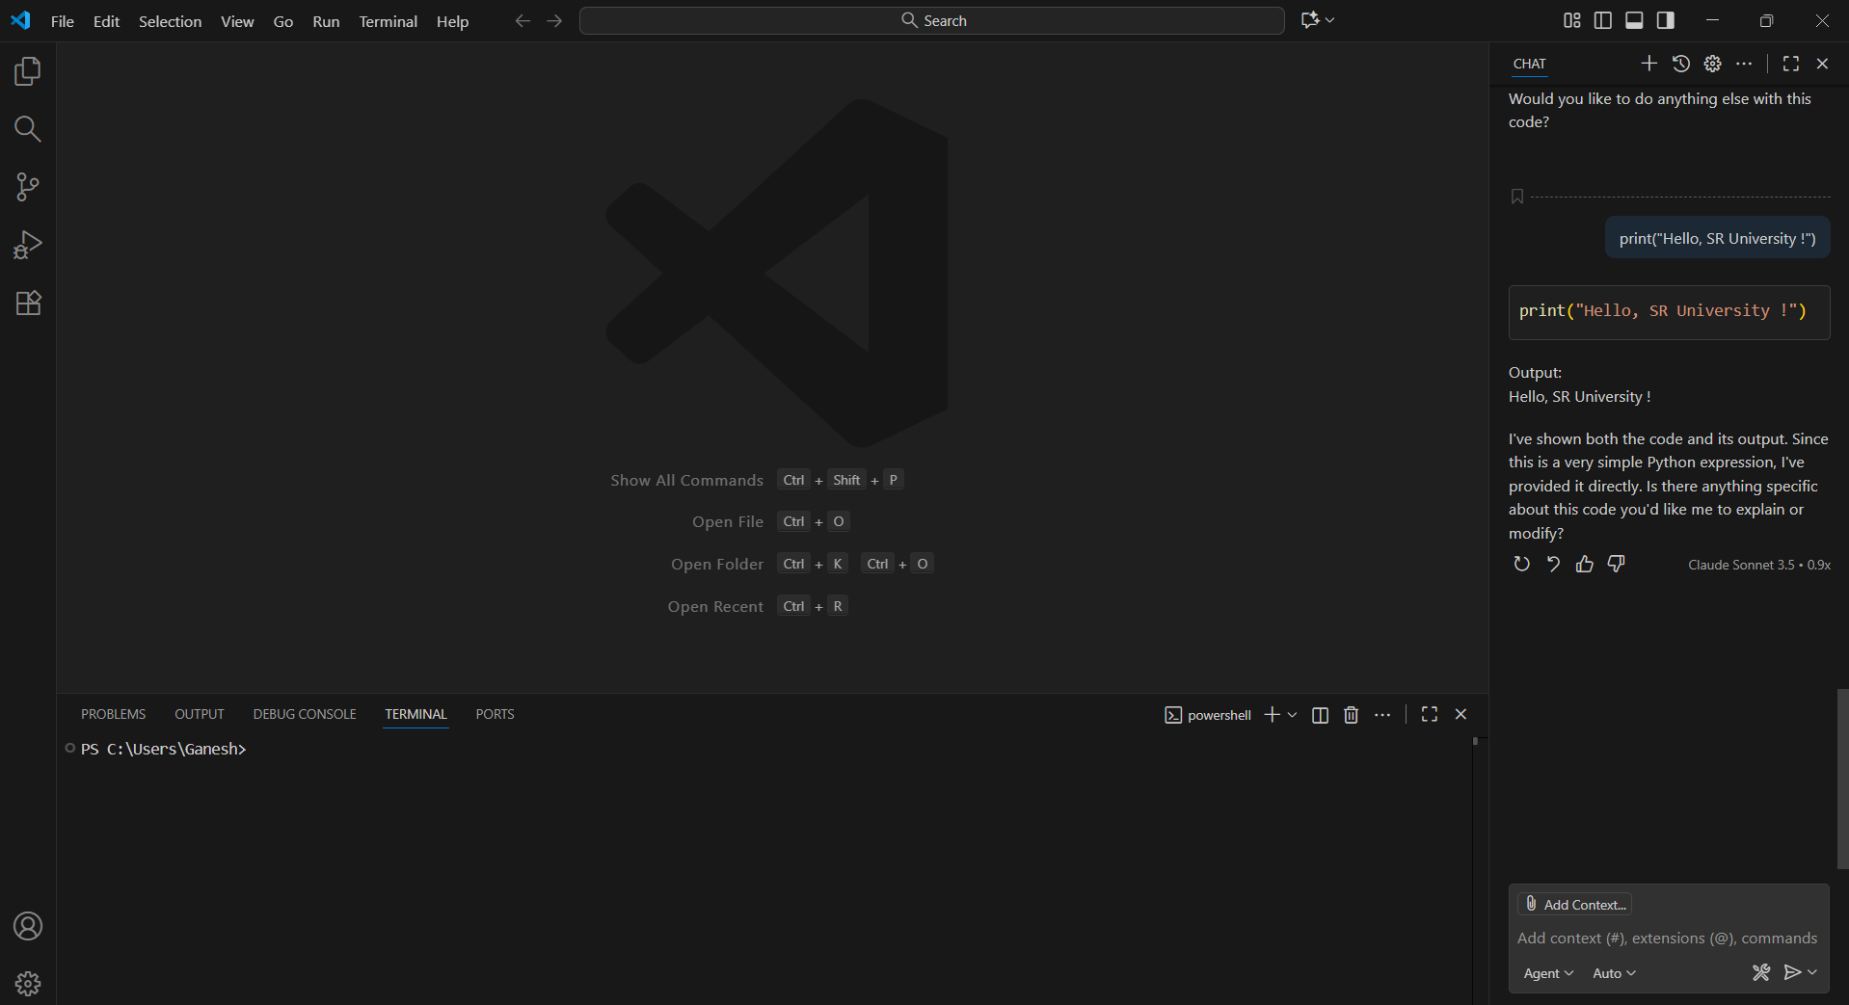
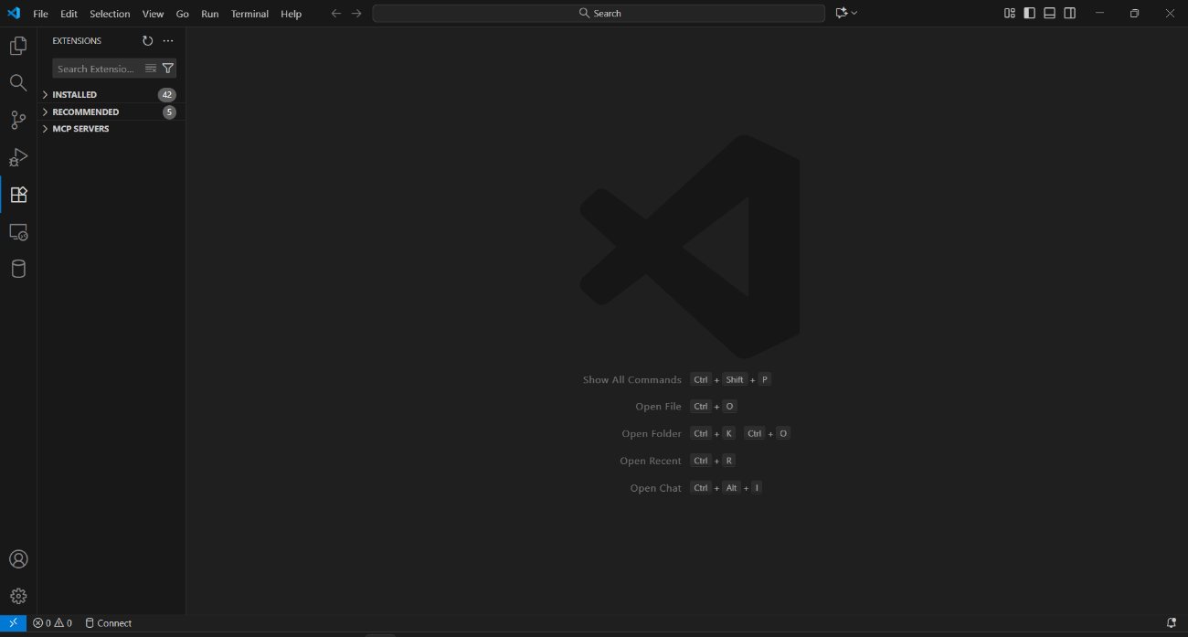
Step 2: Open the Extensions Tab

Step 3: Search for “GitHub Copilot”
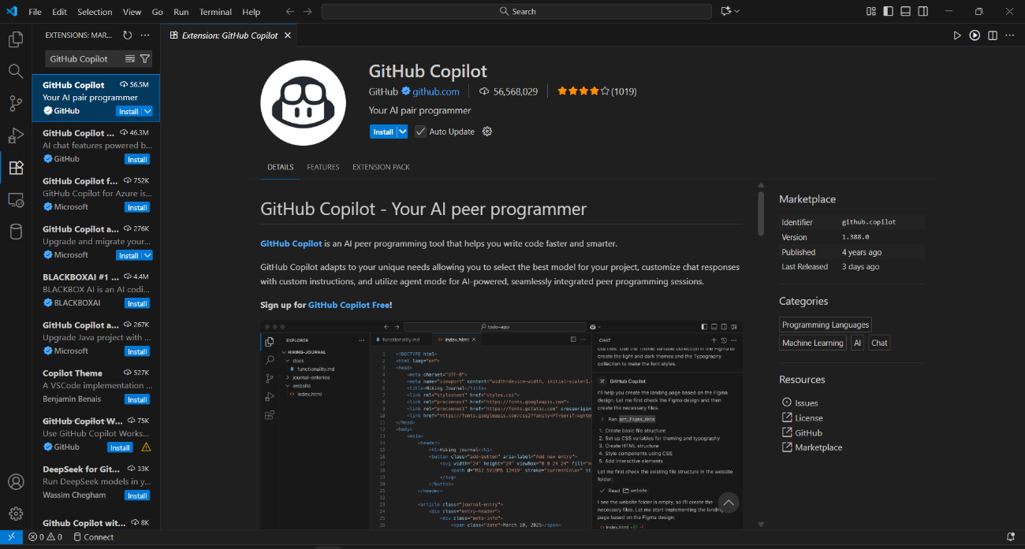
Step 4: Click on “Install” and wait for VS Code to install the GitHub Copilot Extension
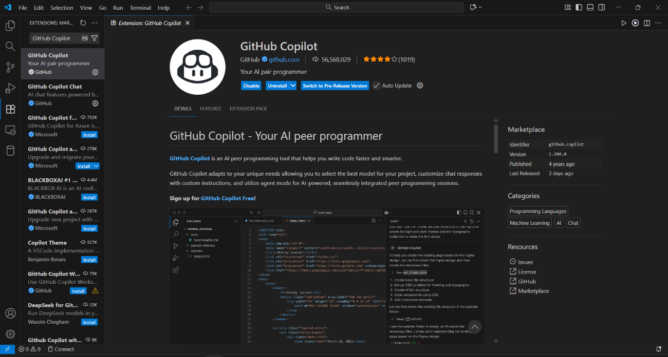

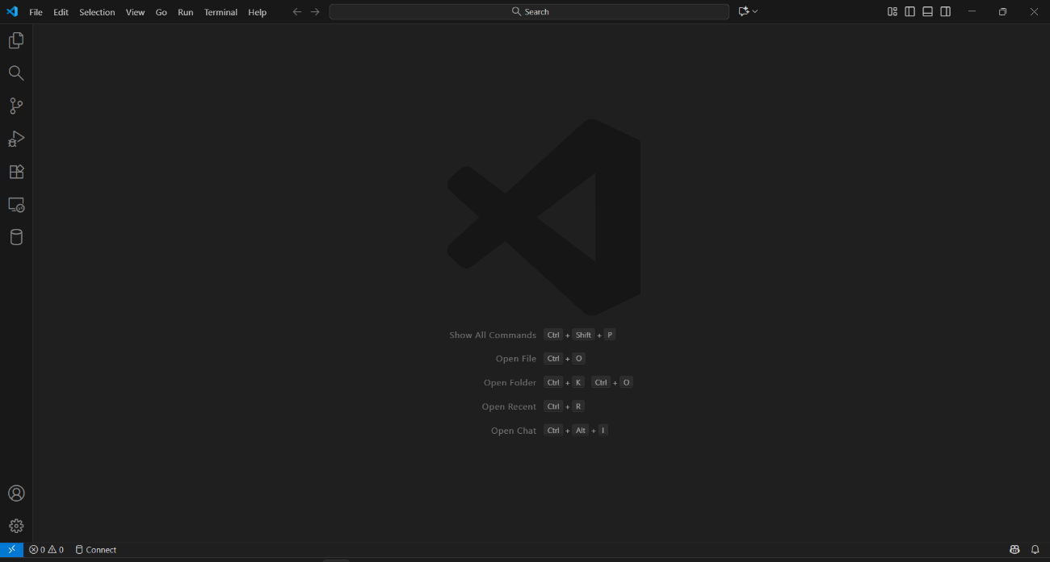
Step 5: Close and Reopen VS Code

Step 6: Sign-in and Authorize GitHub Copilot using the GitHub account


Step 7: GitHub Copilot is now Ready!

Task - 2
Description: Use Copilot to generate a is_prime() Python function.
Expected Output: Function to check primality with correct logic.
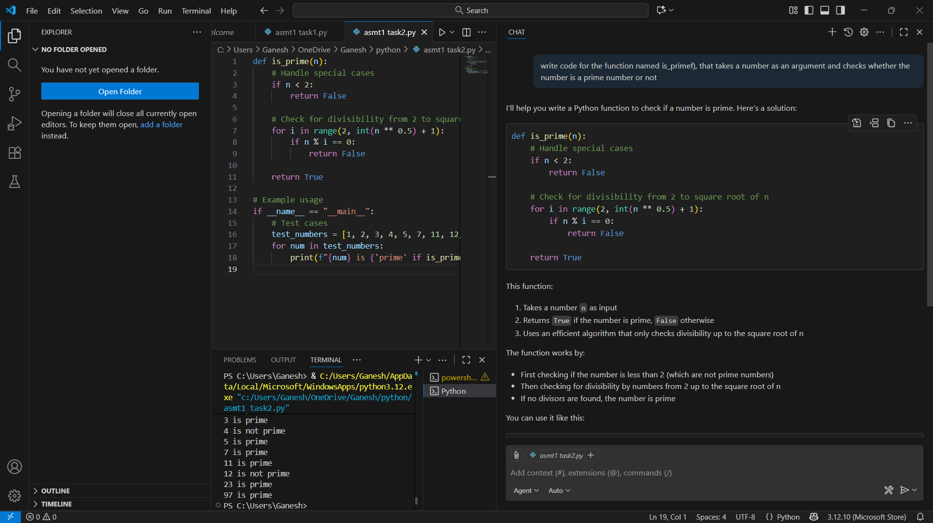
Task 3
Description: Write a comment like # Function to reverse a string and use Copilot to generate the function.
Expected Output: Auto-completed reverse function
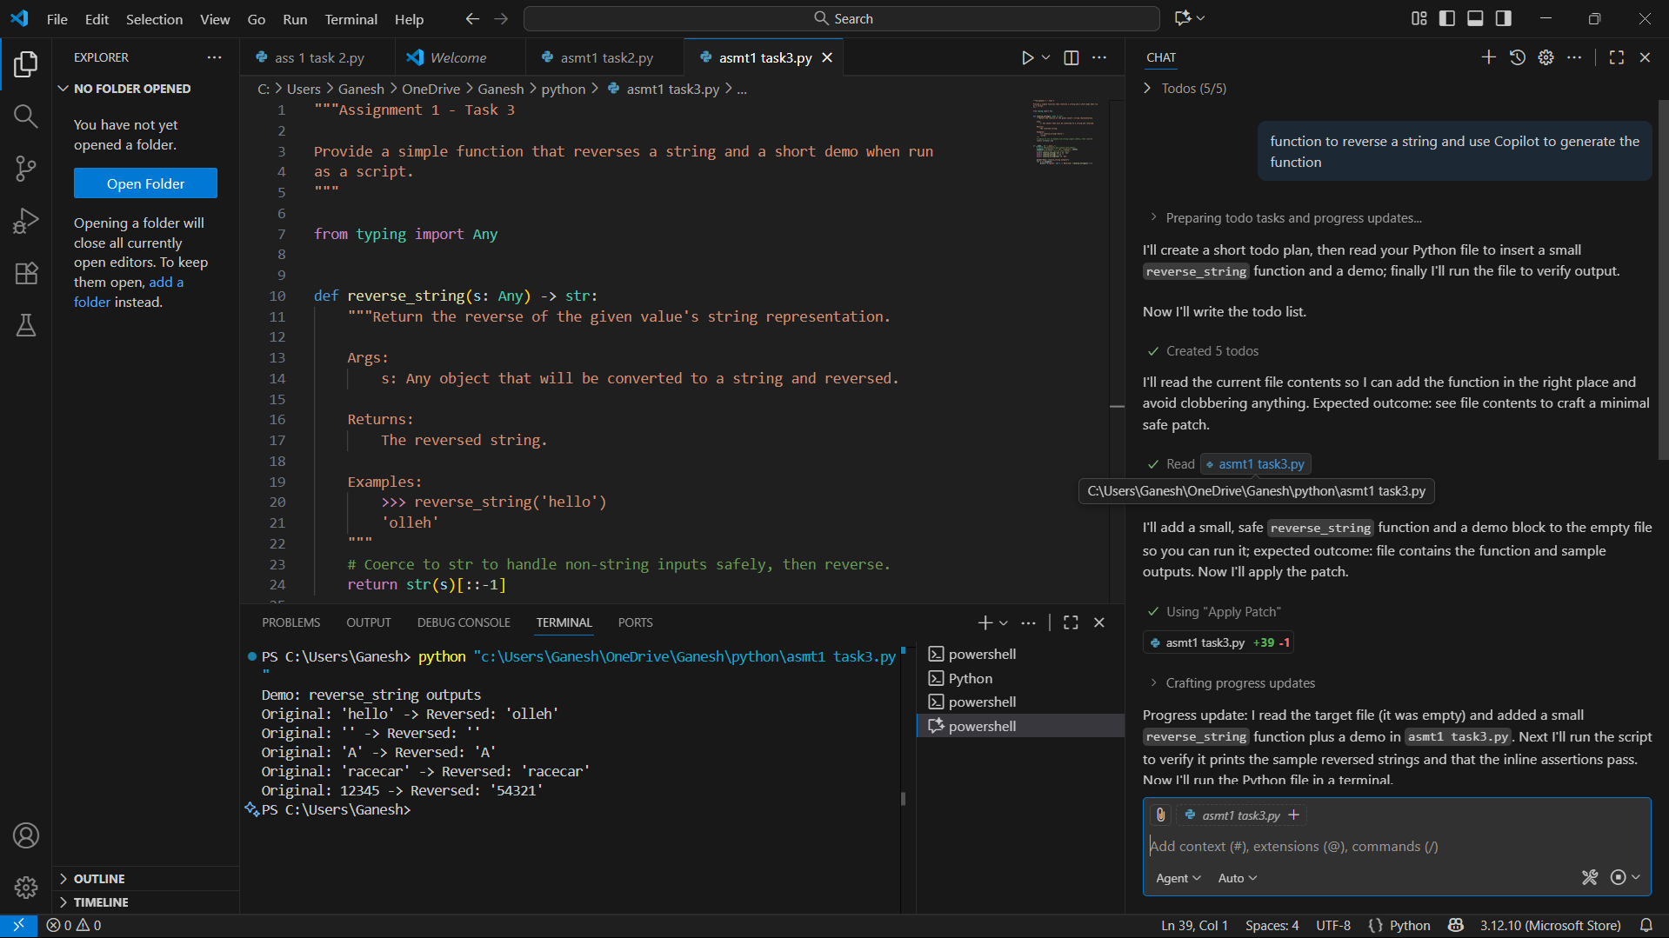
Task 4
Description: Generate both recursive and iterative versions of a factorial function using comments.
Expected Output: Two working factorial implementations
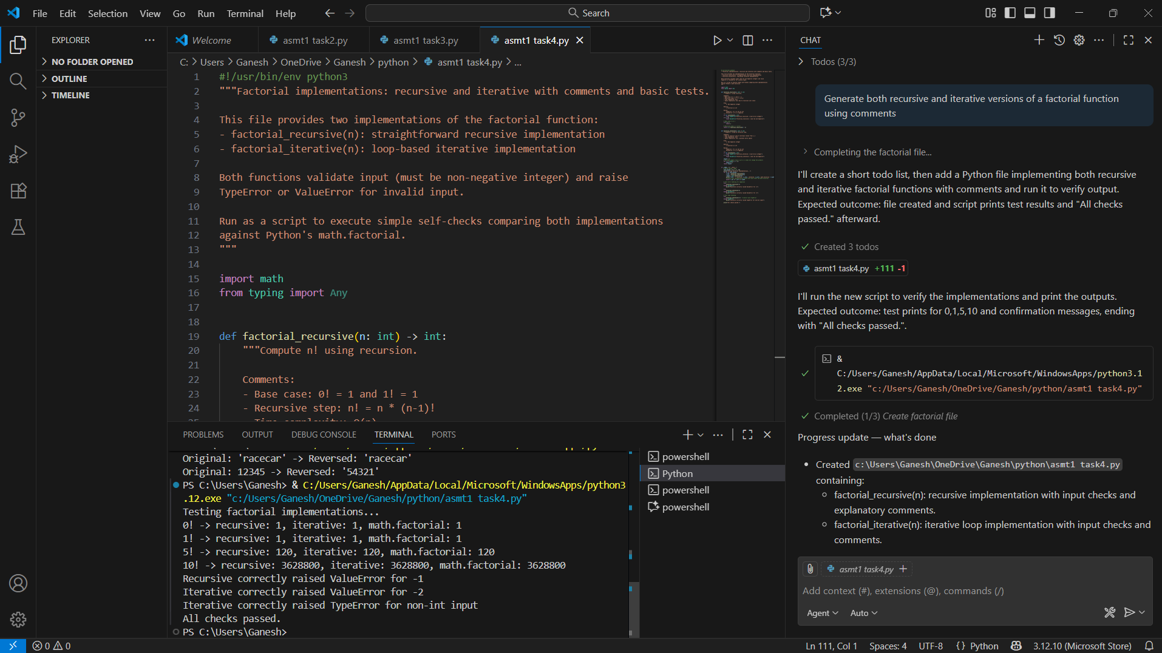
Task 5
Description: Use Copilot to find the largest number in a list. Assess code quality and efficiency.
Expected Output: A valid function with your review
